Launching EC2 Machine and SSH using Putty

Lab Details

1. This lab walks you through the steps to launch and configure a virtual machine in the Amazon cloud.
2. You will practice using Amazon Machine Images (AMI) to launch an Amazon EC2 Instance.
3. You will use key pairs for SSH authentication to log into your instance.
4. AWS Region: **US East (N. Virginia) us-east-1**

Architecture Diagram

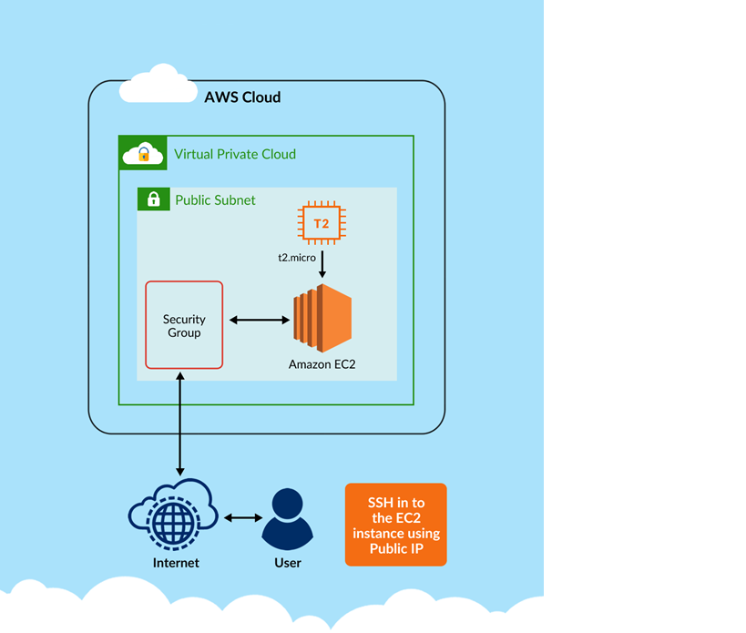

Task Details

1. Log into AWS Management Console.
2. Launch an Amazon Linux Instance from an Amazon Linux AMI 2
3. Find your instance in the AWS Management Console.
4. SSH into your instance for Mac Users.
5. SSH into your instance for Windows Users.
6. Run a few other helpful commands.
7. Validation of the lab